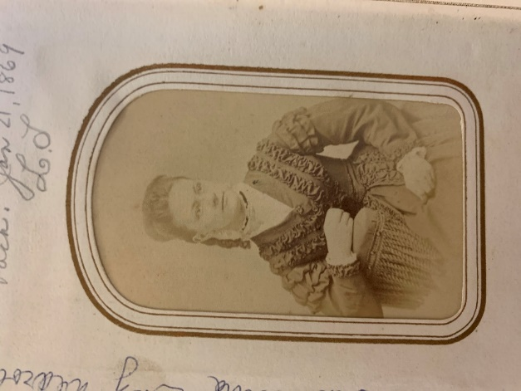**Medrow family**

**Elizabeth Schaich (**February 5, 1851-November 15, 1926), 23, married **Paul Medrow** (1850-1905) on September 24, 1874. Paul was one of four children born to Carl, who in the United States called himself Charles (1819-1905), and Caroline (Thiele?) (1823-1907).[1] Charles was born in Mecklenburg, Germany, married Caroline of Prussia, and had two sons, Paul and Emil (1852 -1940), before deciding to emigrate. He and his family embarked from Hamburg and crossed the Atlantic on the ship *Donau*, arriving in New York City on June 30, 1855.

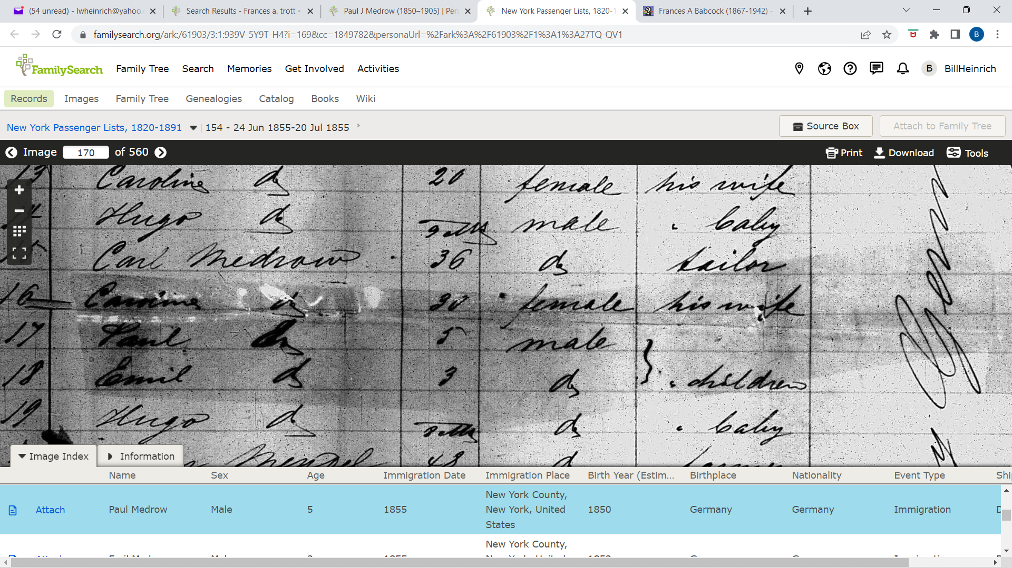

*Donau* passenger list showing Charles, Caroline, Paul and Emil

The Medrow name does not appear in the Rochester city directory before 1864 so we can assume the family lived in other locales before arriving in Rochester. During this period, they had another son **Charles Medrow Jr.** (c1863-1890) who died of nephritis at 27, and a daughter **Clara Medrow** (1858-1866) who died of scarlet fever at age eight.[2] Charles Sr. suffered the misfortune of having his leg amputated in 1872 after it failed to mend properly. The Medrows worked in Rochester’s booming garment industry. Charles and Charles Jr were tailors; Paul was a cloth cutter, possibly a rung up from a tailor, at 63 Mill Street. Paul and Elizabeth lived with the Medrow family at 545 North Clinton, not far from Elizabeth’s family. Paul was a member of the International Order of Odd Fellows and active in local politics.

**Paul’s brother Emil:** Emil was a tailor and salesman. He married Katherine Stolz (1847-1934) and had a daughter Ida (1885-1931). Emil left for Chicago, alone, in 1901. He eventually returned to Rochester about 1920 and lived at St. John’s Home before dying in 1940. Ida married Charles L. Kohl (1867-1945) in 1904 and while living in Pennsylvania had a daughter, Katherine (c1906-2001) who married Raymond B. Duffy (c1902-1986), a musician and insurance salesman. Ida and Charles divorced, and Ida married WWI veteran Clarence Dunlop Maddy (1887-1966) in Manhattan on July 18,1925. Raymond and Katherine had a daughter, Beverley Ann (c1927-)

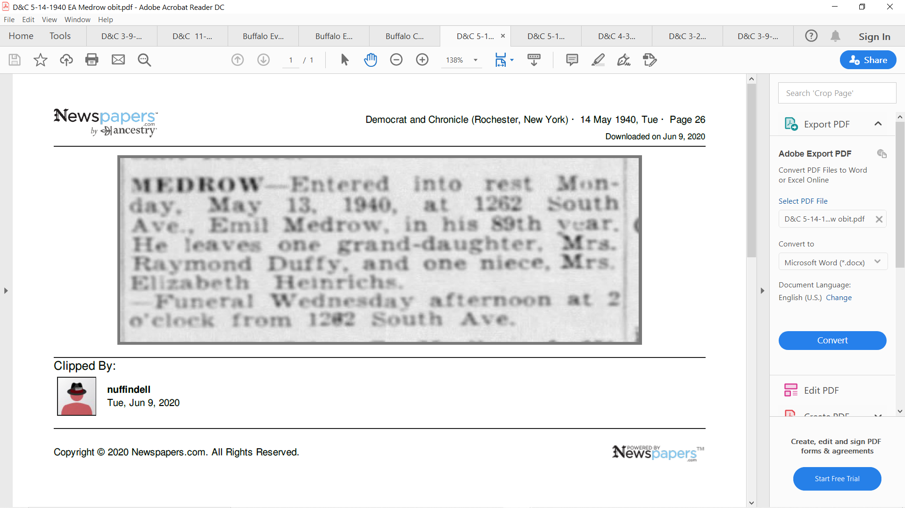 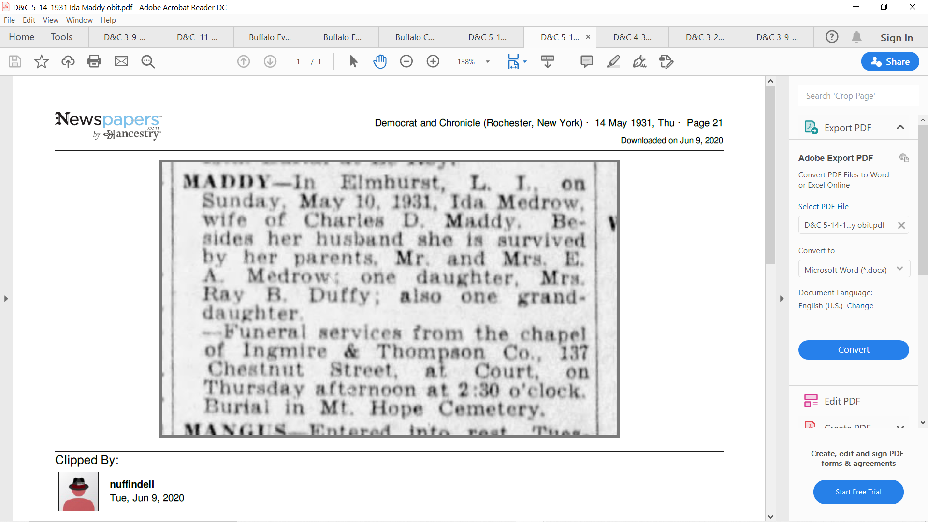

*Democrat and Chronicle* May 14, 1940May 14, 1931

Paul and Elizabeth had four children. Their first was born on June 24, 1875 was named **Henry Carl Medrow**, but he died of diphtheritic laryngitis at age six in 1881. The second, also a boy, was born March 7, 1877 and was named **Jonathan Henry Child Medrow** (1877-1920), reportedly in honor of the first mayor of Rochester.[3] He was a music teacher, a noted ‘cellist, and married Maria Susan Harlie Tompkins (1882-1971) of Cortland, New York on May 4, 1908. Tompkins counted among her forebearers Alonzo Cornell, father of Ezra who founded the eponymous university, and Daniel Tompkins, founder of Tompkins County, Governor of New York, and Vice President of the United States under James Monroe. She would go on to have a noteworthy career as a violinist, performing with John Philip Sousa and forming her own touring orchestra. Jonathan died of nephritis on his 43rd birthday in 1920 – he is buried in Mt Hope at range 7, lot 49, along with his wife Susan and her second husband Edmund Query. The third was a girl who lived only a day in January 1879.

The fourth child was Katherine Amelia Medrow, who was born on July 3, 1880. She would go on to marry William G. Heinrich on December 30, 1902.

1905 proved to be a bad year for the Medrow family. Charles died on May 25 at the age of 86. Then, Paul lost his job as a cutter and went to Buffalo in mid-December in search of work. A news report in the Buffalo *Courier* states that he took a room above the Kennedy & Cannon saloon at 23 West Eagle Street. On December 19, the maid went to his room and found him dead. According to the medical examiner, the 55-year-old Paul had expired of heart disease in his sleep. Paul and other Medrows are buried in Mt. Hope Cemetery at range 1, lot 26.

Charles’ widow Caroline lived another two years, dying at age 83 in March 1907. She is buried with her husband and son. Paul’s wife Elizabeth died at age 74 on November 15, 1926. She is buried in Mt. Hope at section U, lot 83 with her daughter Katherine, who died on her 80th birthday July 3, 1964. The different resting places are one indication that Paul and Elizabeth did not enjoy a happy marriage.

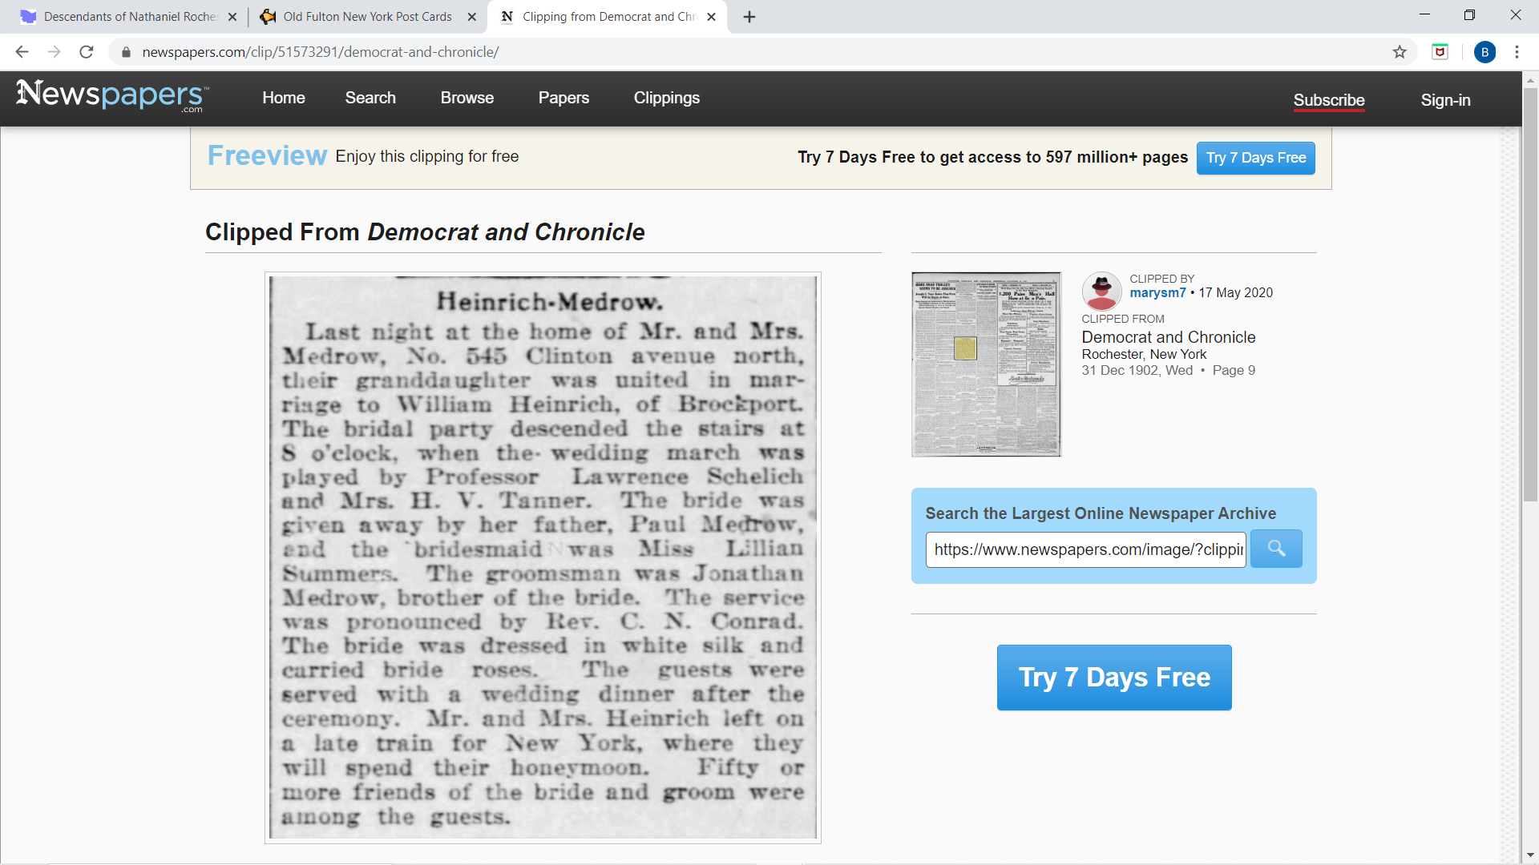

*Democrat and Chronicle*, December 31, 1902

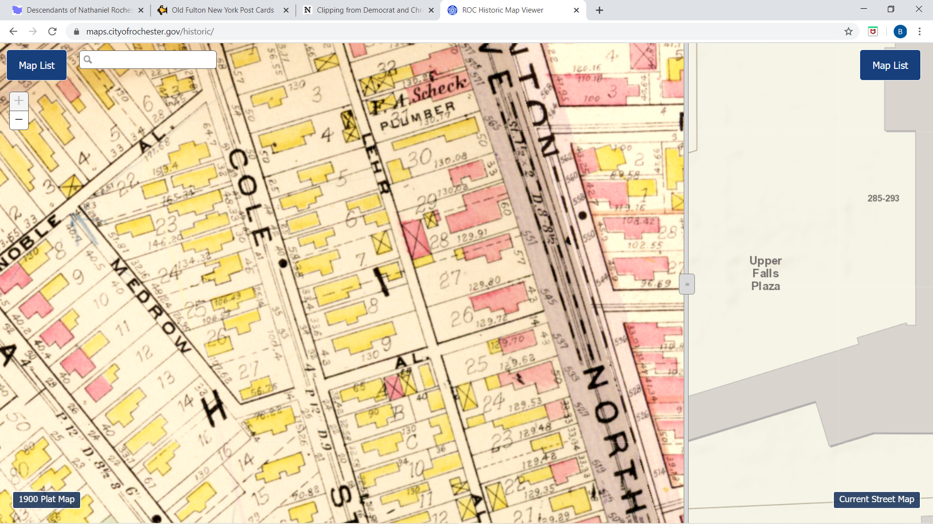

Interestingly, 545 Clinton Avenue North is next to “Medrow Alley”

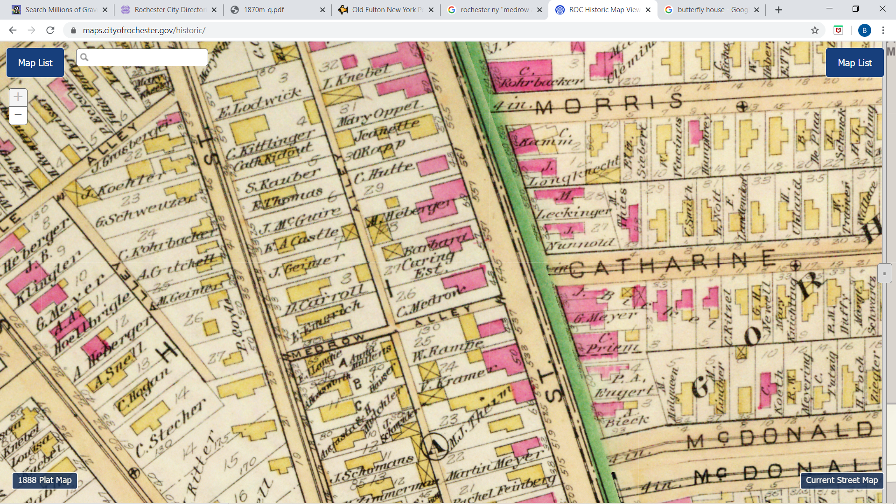

1888 map

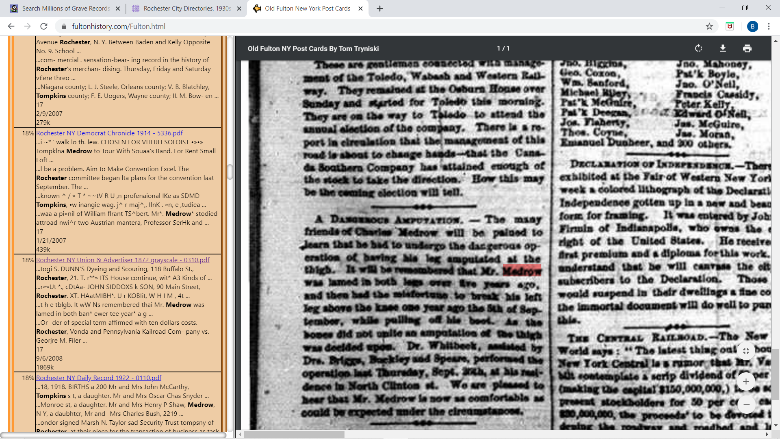

Rochester *Union and Advertiser* September 30, 1872

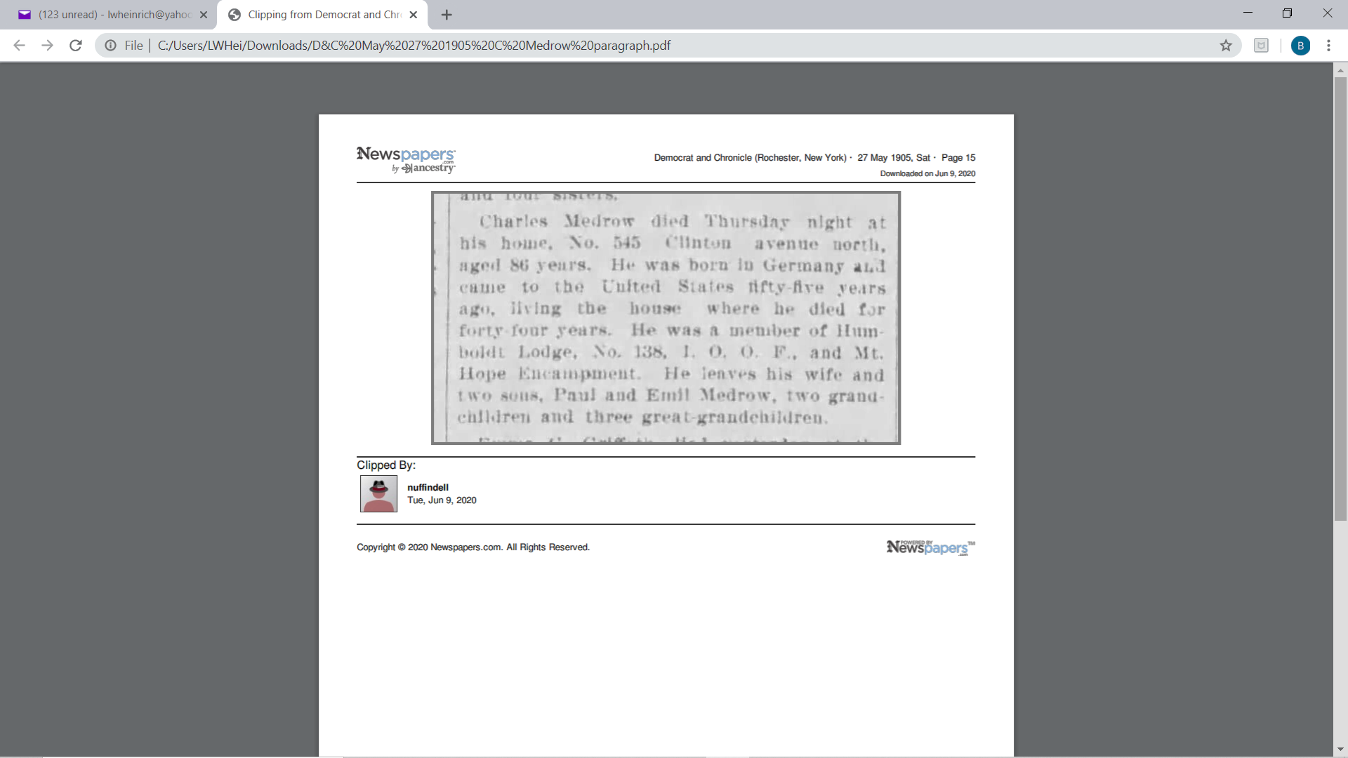 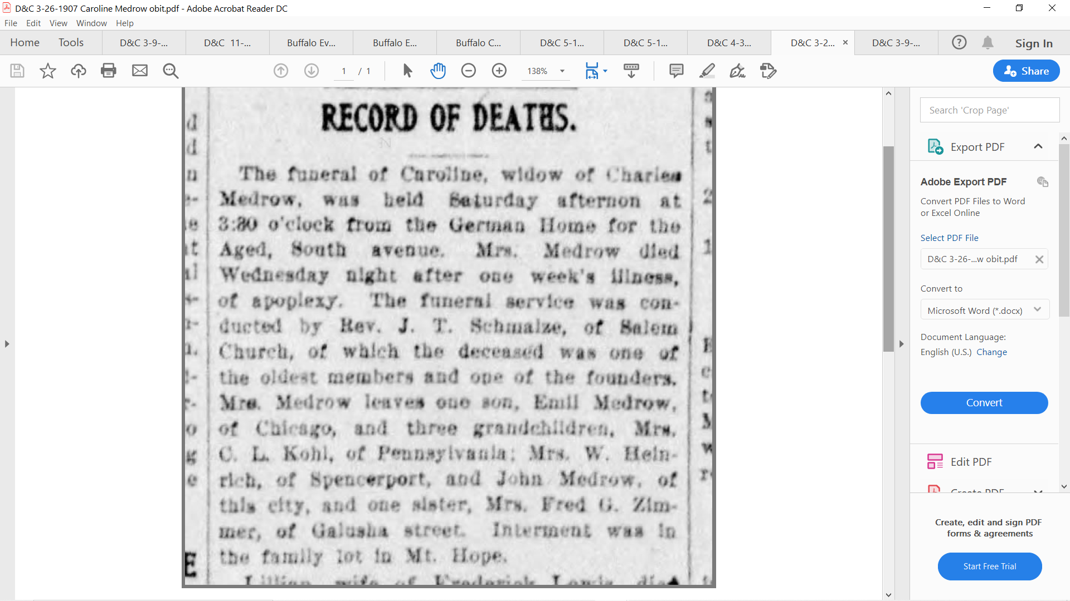

Democrat & Chronicle May 25, 1905 Democrat & Chronicle March 26, 1907

{Fred G. Zimmer was a lock tender living at 28 Galusha St.}

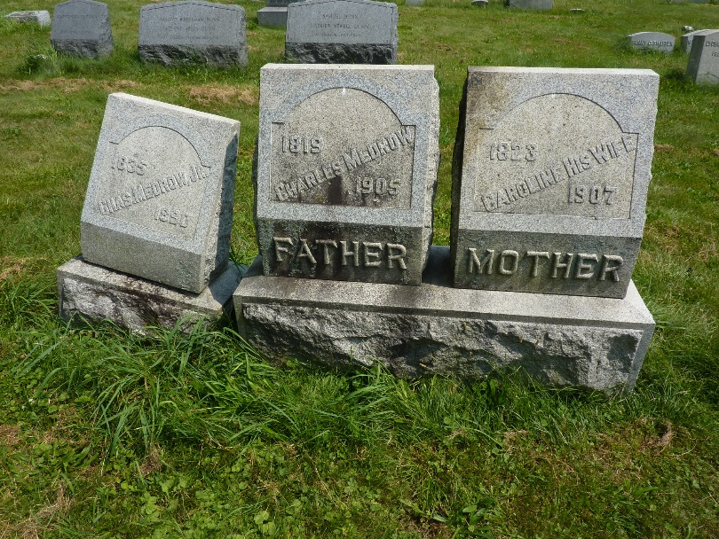 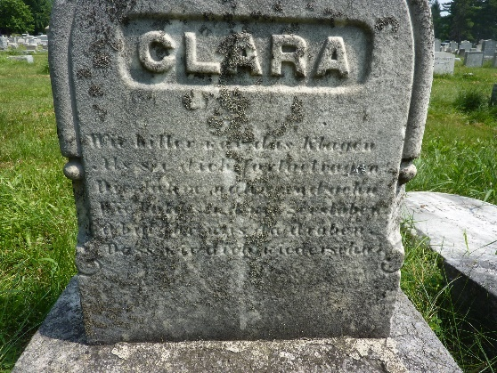

Charles Jr, Charles, Caroline, and Clara in Mt Hope at range 1, lot 26

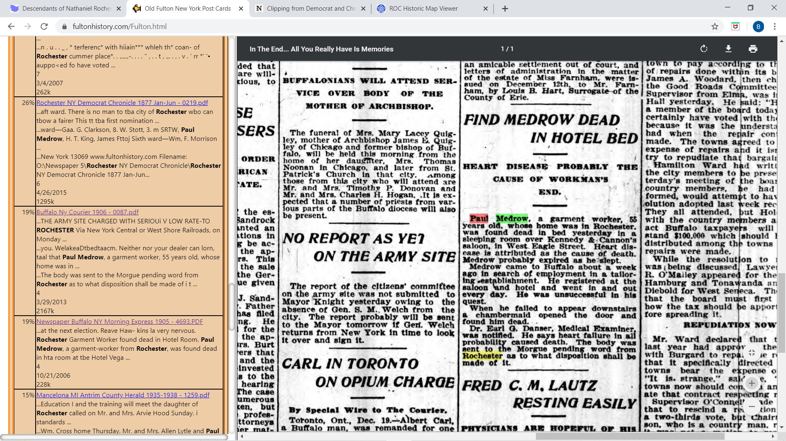 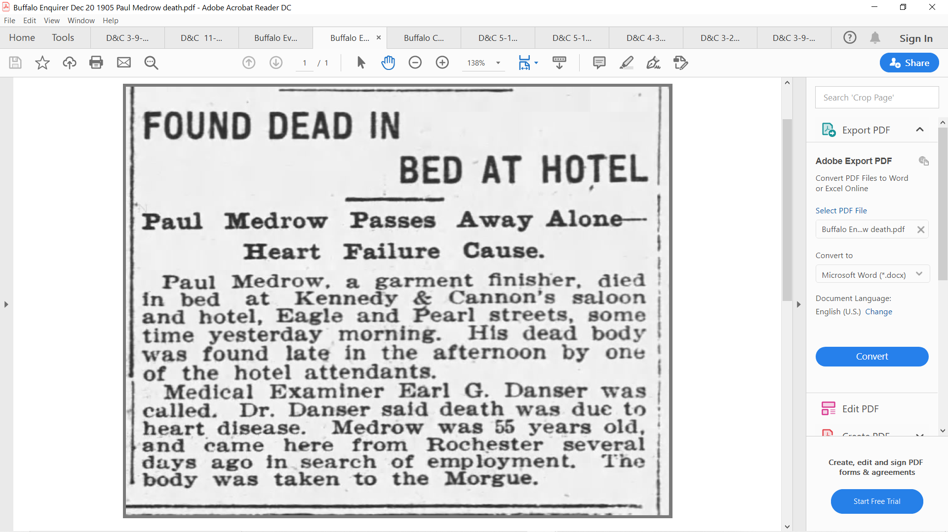

Buffalo *Courier* December 20, 1905 Buffalo *Enquirer* December 20, 1905

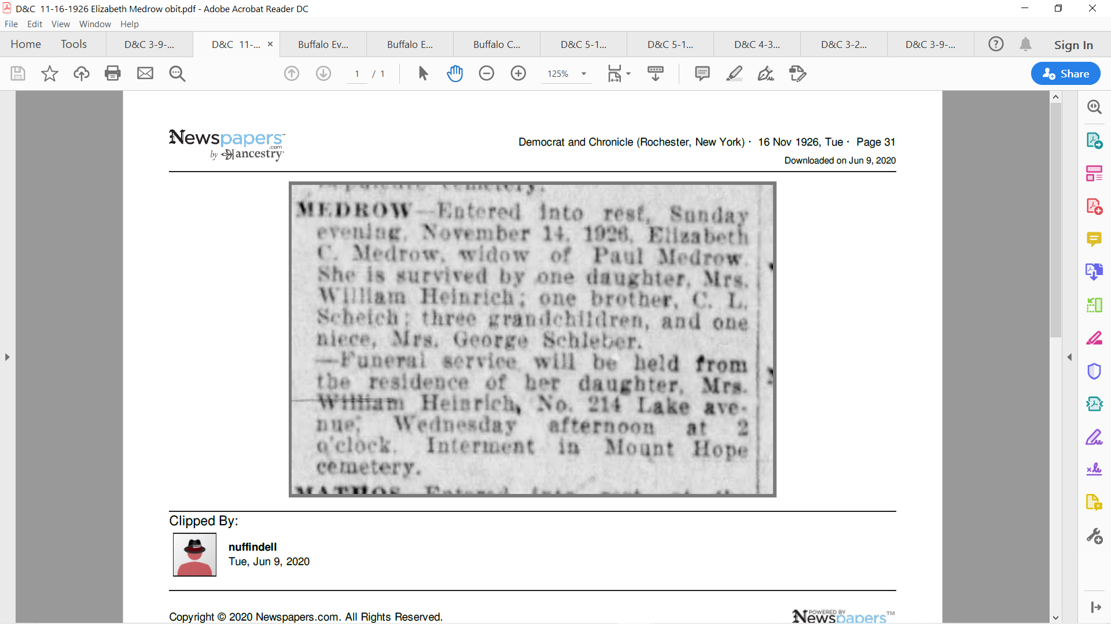

*Democrat and Chronicle and Herald*, November 16, 1926

(Elizabeth *Schaich* Medrow)

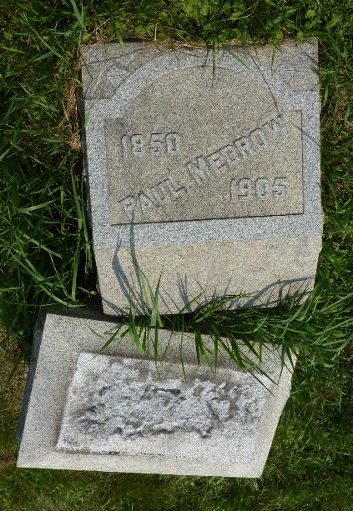 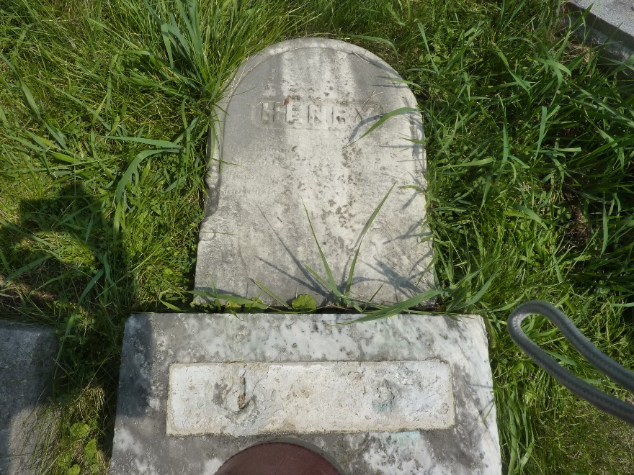

Both Paul and son Henry’s stones have toppled (2021)

**Jonathan Henry Child Medrow and Maria Susan Tompkins**

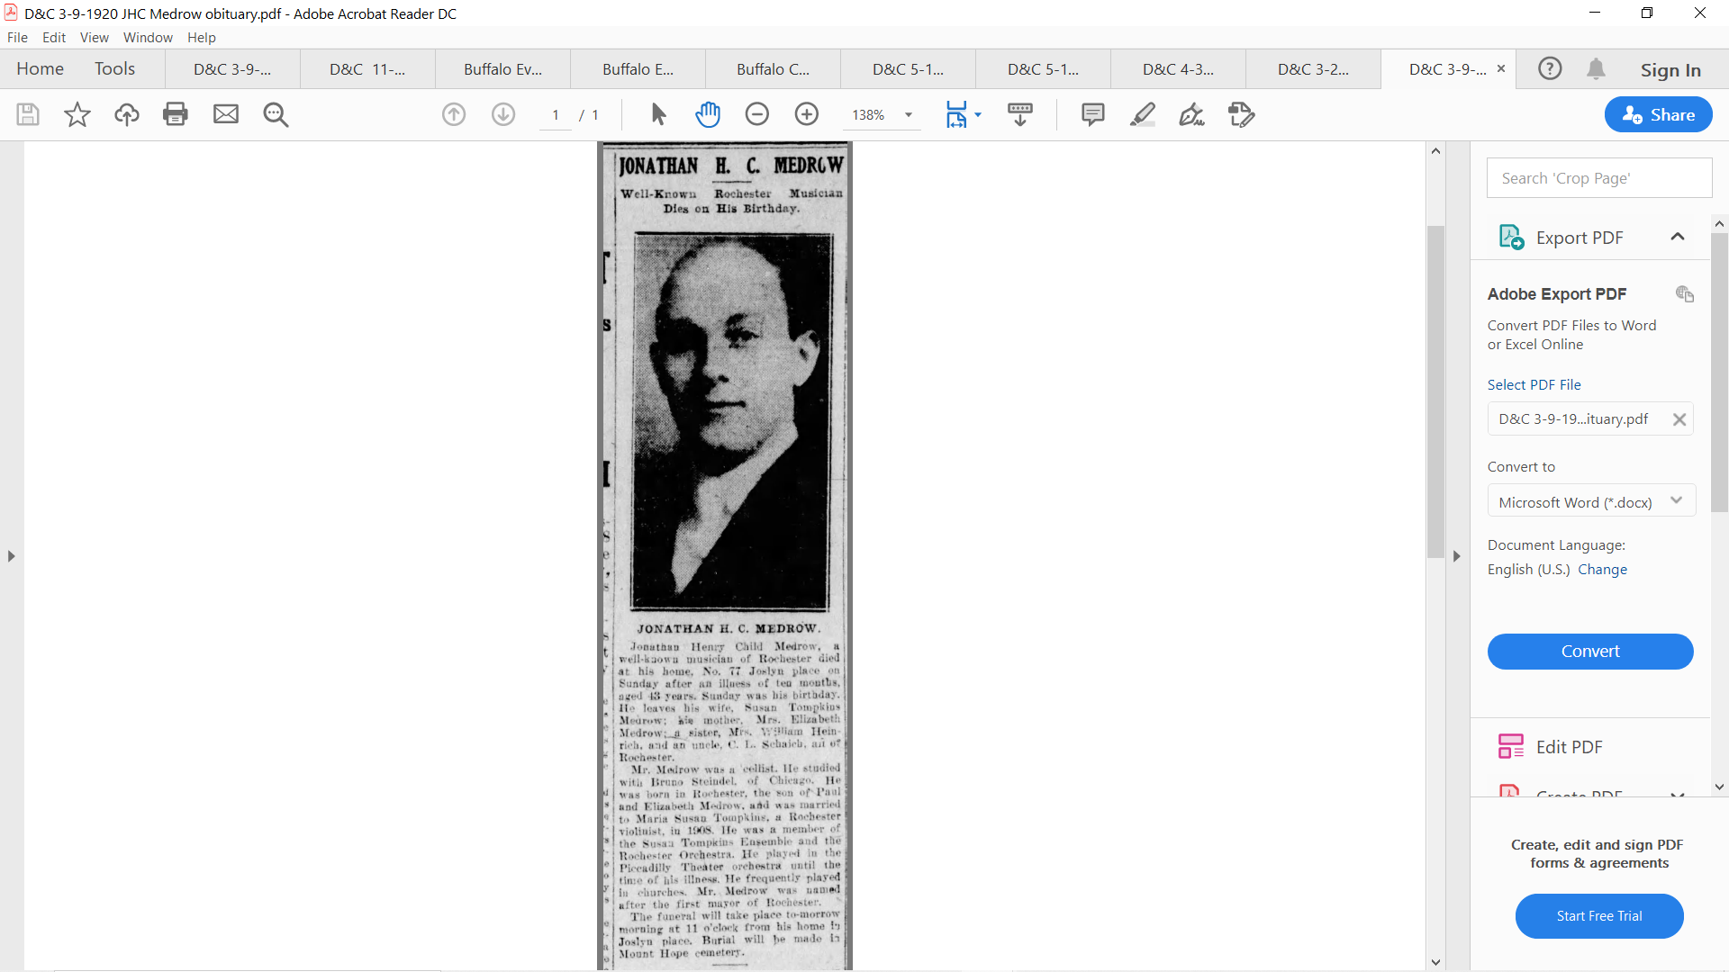 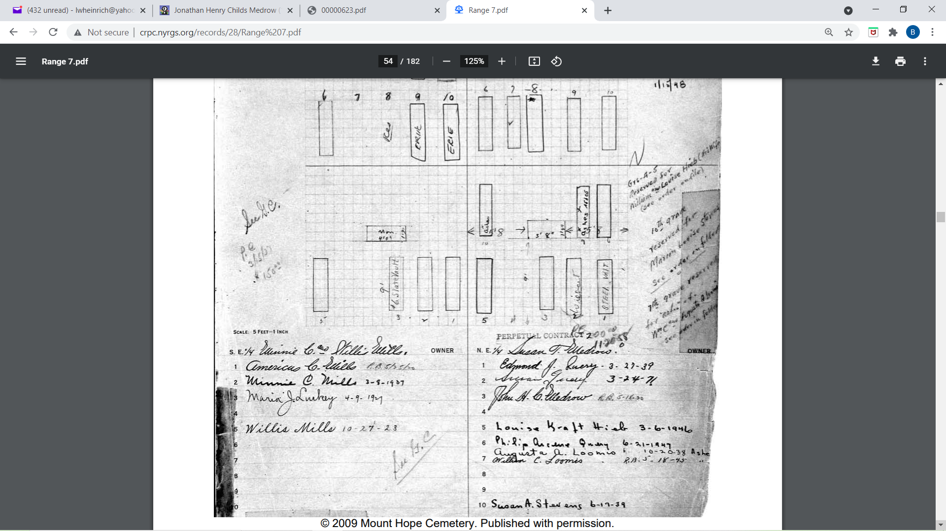

*Democrat and Chronicle* March 9, 1920 Mt. Hope range 7, lot 49

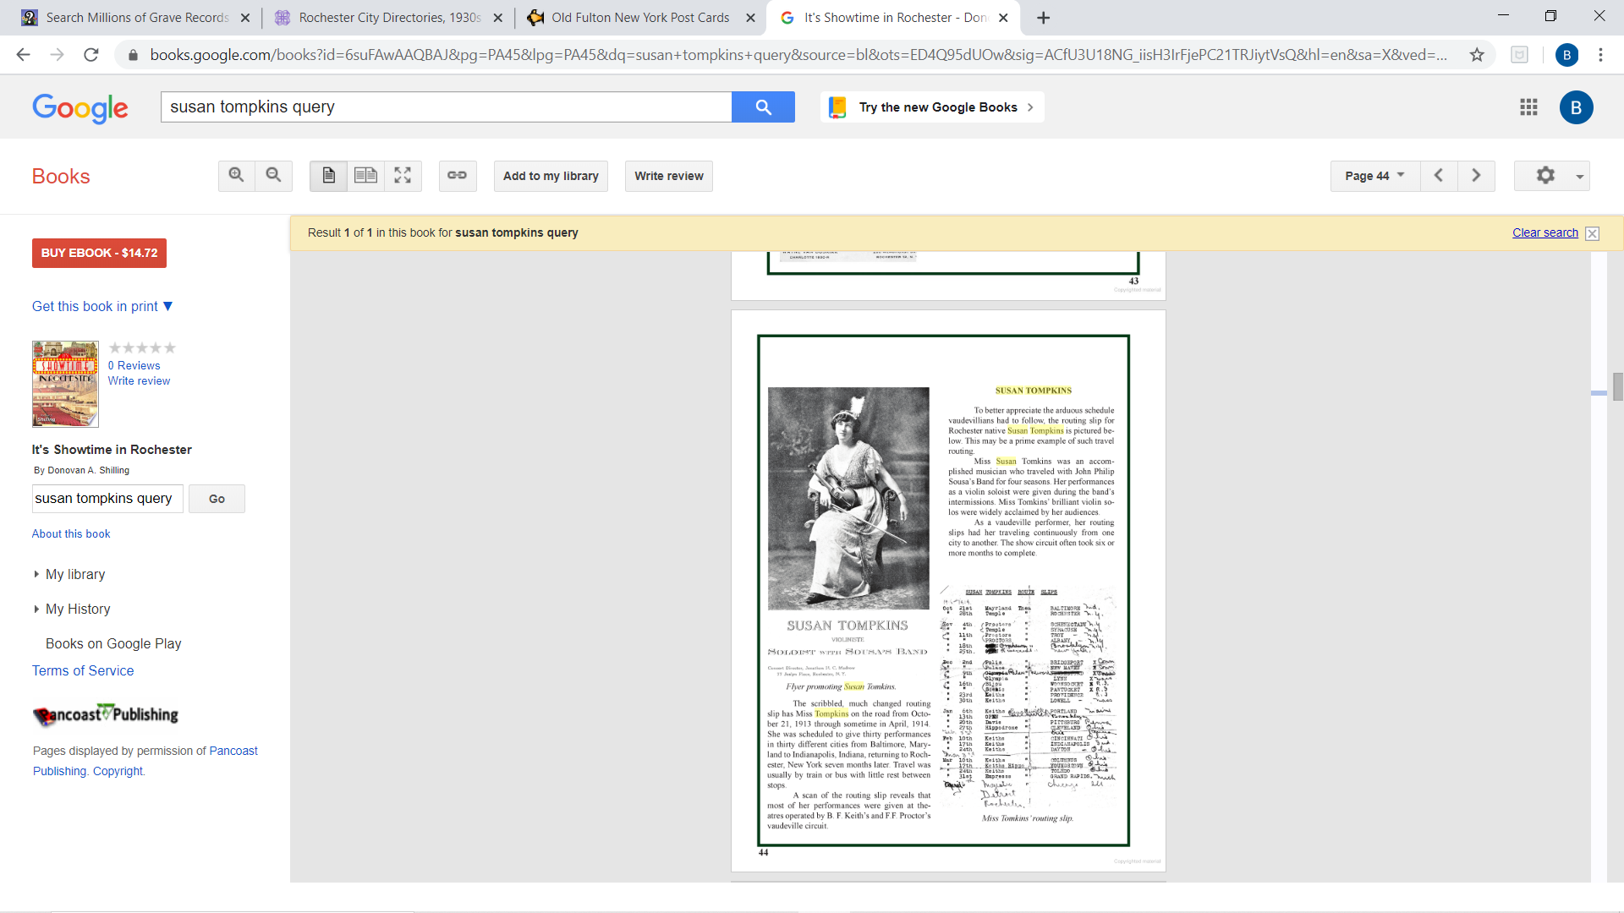

Jonathan H. C. Medrow’s wife

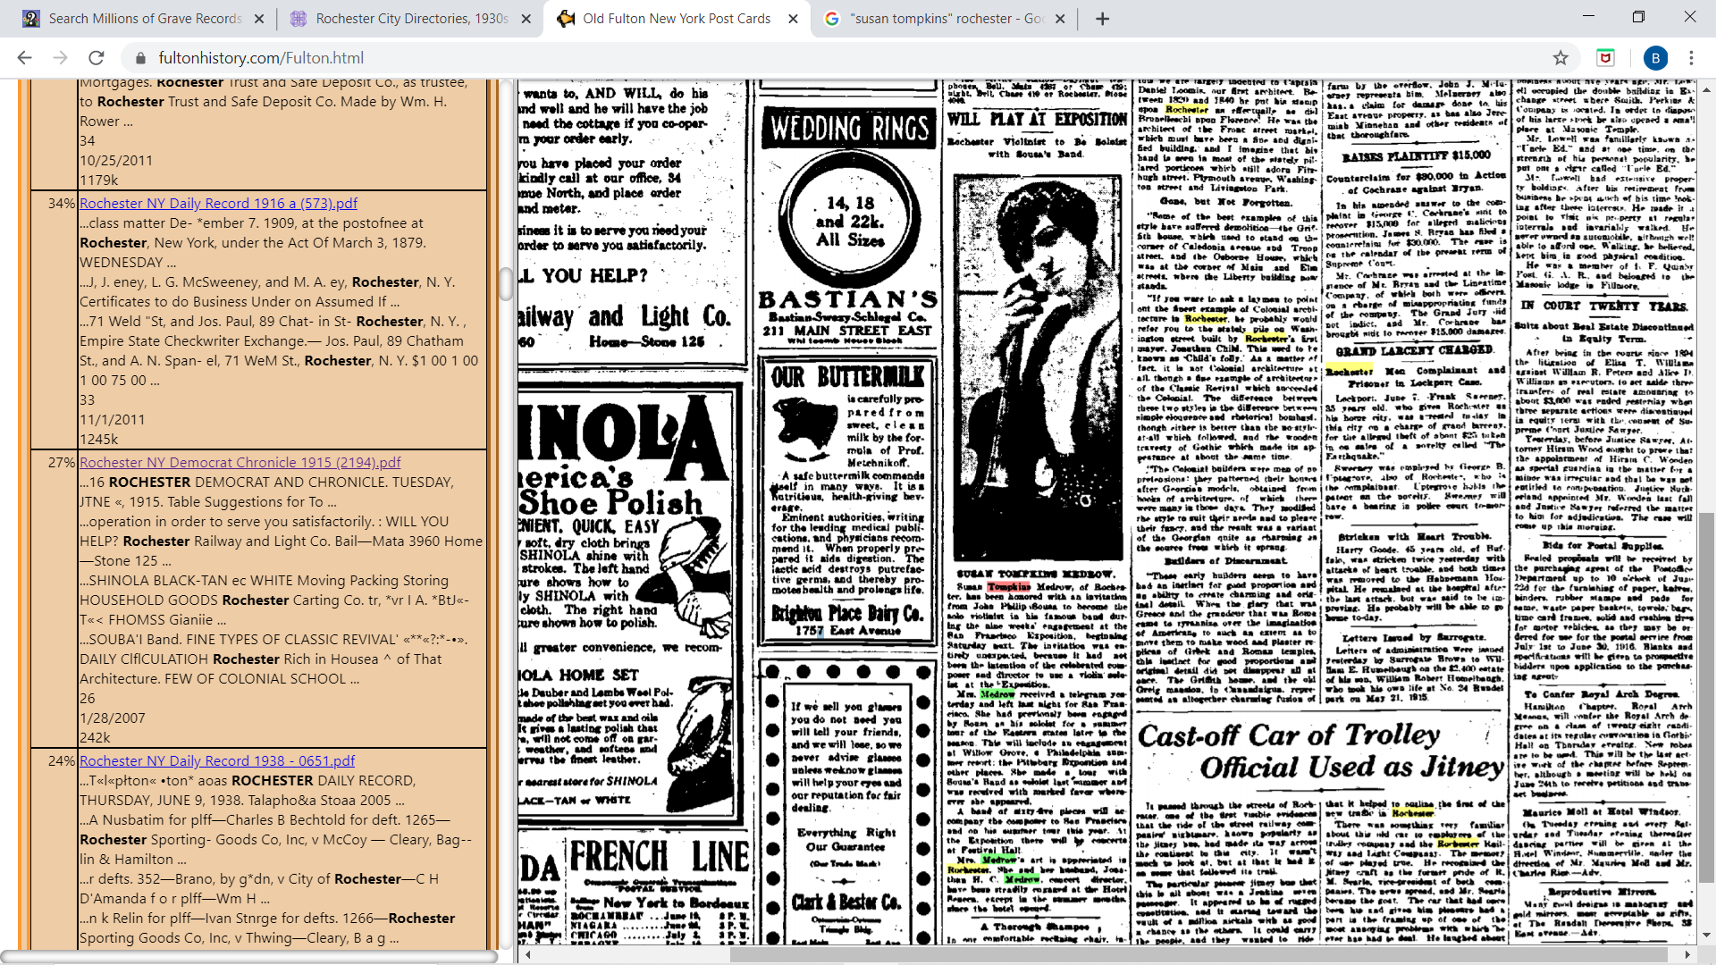 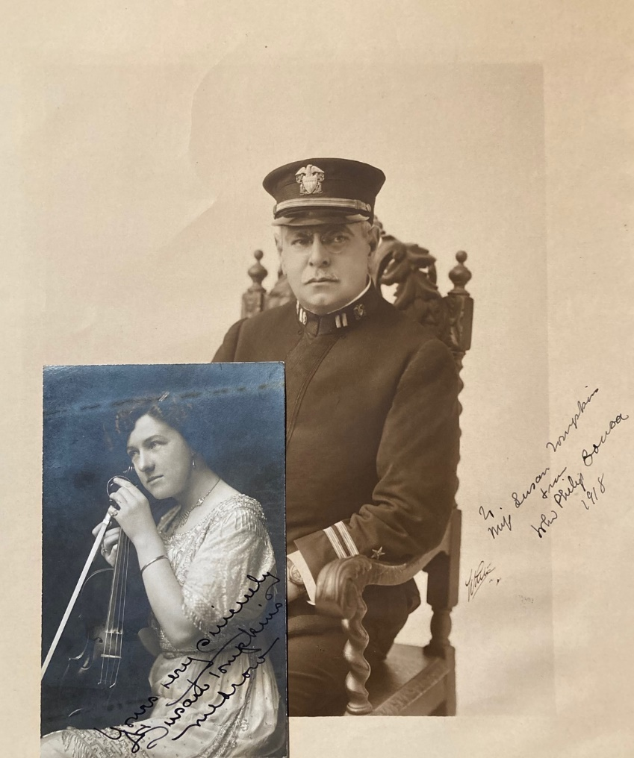

*Democrat and Chronicle* June 8, 1915 and John Philip Sousa 1918

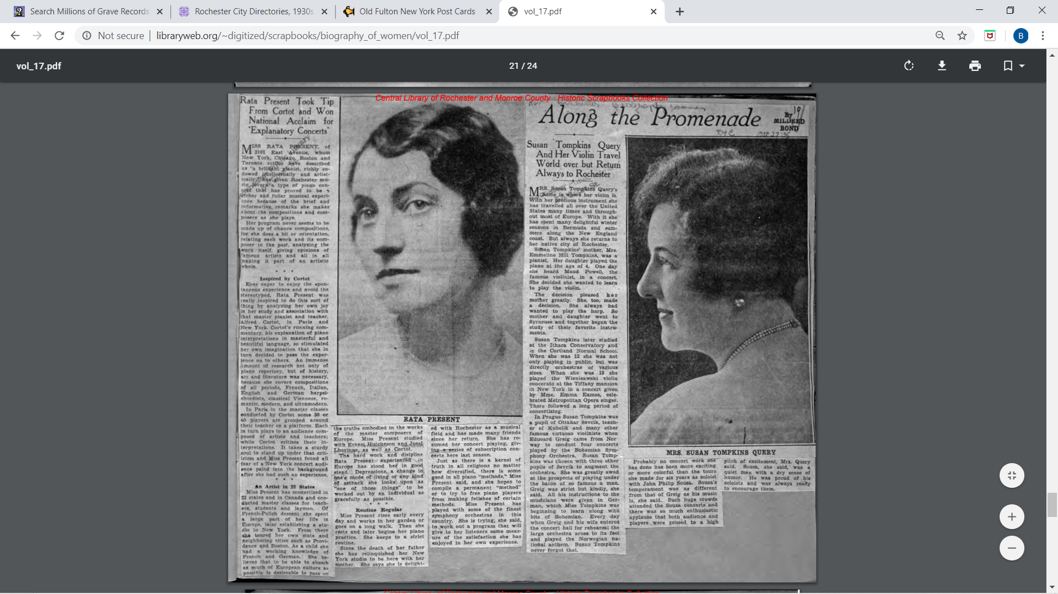

*Democrat and Chronicle* October 27, 1935 (continued next page)

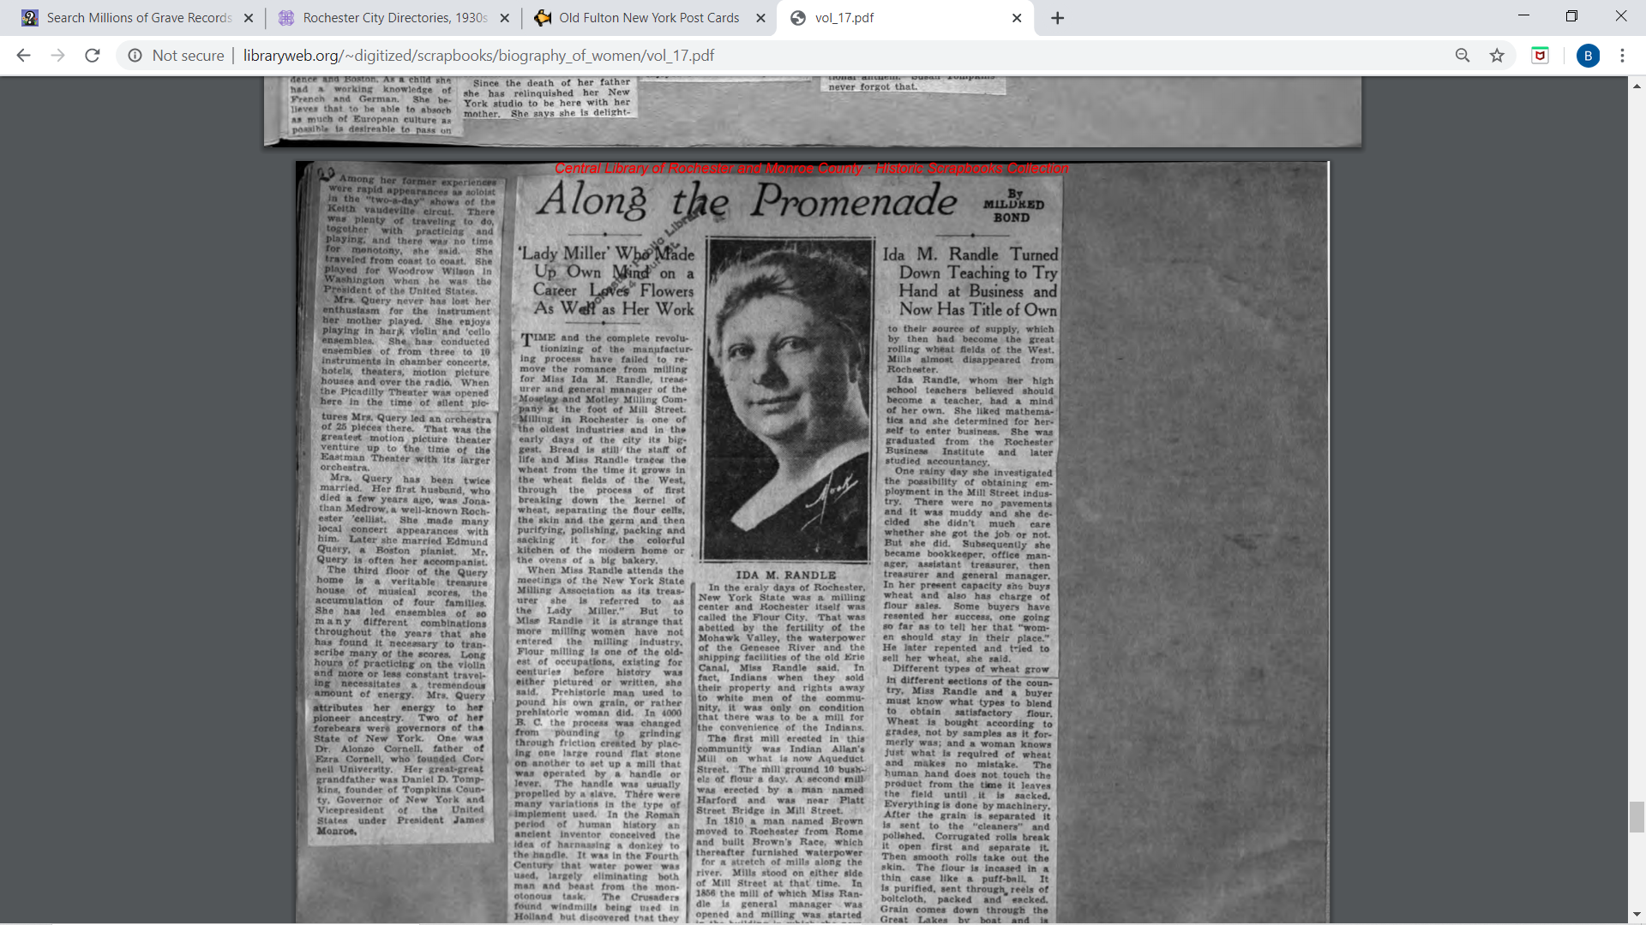

1. Caroline’s family name remains a mystery. She had a sister who was married to Fred Zimmer
2. Clara Medrow is misspelled “Madrow” in the Mt Hope Cemetery records.
3. Jonathan Child was the first mayor of Rochester (1834-35) and married to the daughter of city father Nathaniel Rochester. Jonathan Henry Child was Rochester’s grandson.